TASK 14:
import java.util.*;

class Solution {
public ListNode mergeKLists(ListNode[] lists) {
PriorityQueue<ListNode> pq = new PriorityQueue<>((a, b) -> a.val - b.val);
for (ListNode node : lists) {
if (node != null) {
pq.offer(node);
}
}
ListNode dummy = new ListNode();
ListNode cur = dummy;
while (!pq.isEmpty()) {
ListNode node = pq.poll();
cur.next = node;
cur = cur.next;
if (node.next != null) {
pq.offer(node.next);
}
}
return dummy.next;
}
}

Case 1:
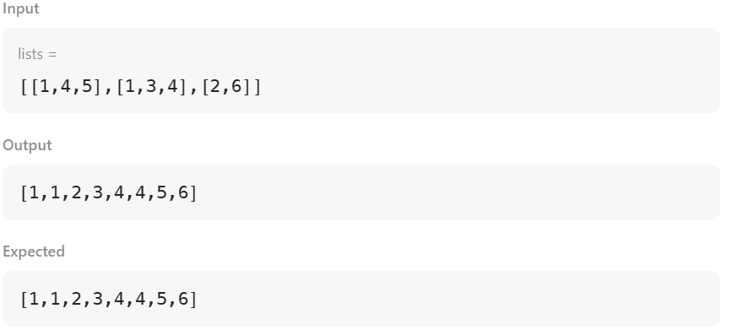
Case 2:
